Name: _______________________________________________
Differentiation Exam Questions
Topic Test and Revision
Date:
Time: 500
Total marks available: 384
Total marks achieved: ______

Calculator Allowed
Mathvault.io

Questions
Q1.
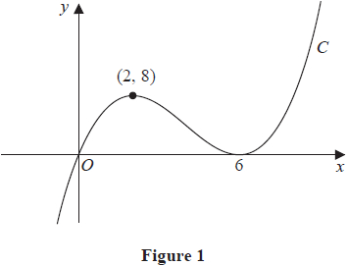
Figure 1 shows a sketch of a curve C with equation y = f(x) where f(x) is a cubic expression in x.
The curve
• passes through the origin
• has a maximum turning point at (2, 8)
• has a minimum turning point at (6, 0)
(a) Write down the set of values of x for which
f'(x) < 0

(1)
The line with equation y = k, where k is a constant, intersects C at only one point.
(b) Find the set of values of k, giving your answer in set notation.

(2)
(c) Find the equation of C. You may leave your answer in factorised form.

(3)

(Total for question = 6 marks)

(Q06 9MA0/01, June 2022)

Q2.
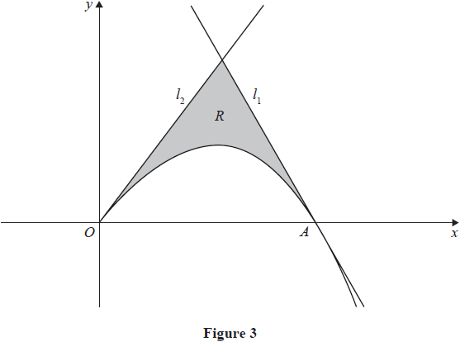
In this question you must show all stages of your working.
Solutions relying entirely on calculator technology are not acceptable.
Figure 3 shows a sketch of part of the curve with equation
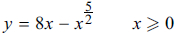
The curve crosses the x-axis at the point A.
(a) Verify that the x coordinate of A is 4

(1)
The line l₁ is the tangent to the curve at A.
(b) Use calculus to show that an equation of line l₁ is
12x + y = 48

(3)
The line l₂ has equation y = 8x
The region R, shown shaded in Figure 3, is bounded by the curve, the line l₁ and the line l₂
(c) Use algebraic integration to find the exact area of R.

(5)

(Total for question = 9 marks)

(Q10 9MA0/01, June 2024)

Q3.
y = sin x
where x is measured in radians.
Use differentiation from first principles to show that
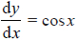
You may
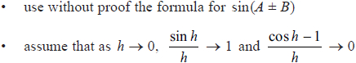

(Total for question = 5 marks)

(Q12 9MA0/01, June 2023)

Q4.
Given that y = x², use differentiation from first principles to show that 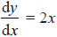

(Total for question = 3 marks)

(Q04 9MA0/01, June 2024)

Q5.
Given that θ is measured in radians, prove, from first principles, that the derivative of sinθ is cosθ
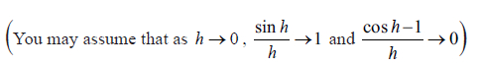

(Total for question = 5 marks)

(Q11 9MA0/02/M, June 2025)

Q6.
f (x) = x³ + 2x² − 8x + 5
(a) Find f ' ' (x)

(2)
(b) (i) Solve f ' '(x) = 0
(ii) Hence find the range of values of x for which f(x) is concave.

(2)

(Total for question = 4 marks)

(Q01 9MA0/02, June 2023)

Q7.
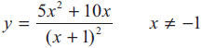
(a) Show that 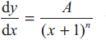 where A and n are constants to be found.

(4)
(b) Hence deduce the range of values for x for which < 0

(1)

(Total for question = 5 marks)

(Q03 9MA0/01, June 2019)

Q8.
y = 4x³ − 7x² + 5x − 10
(a) Find in simplest form
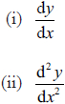

(3)
(b) Hence find the exact value of x when 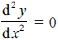

(2)

(Total for question = 5 marks)

(Q01 9MA0/02, June 2024)

Q9.
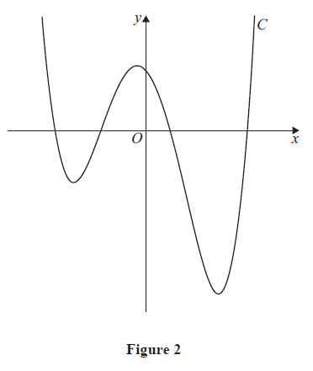

where a is a constant.
Figure 2 shows a sketch of the curve C with equation y = f (x)
Given that C has a local maximum at 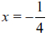
(a) show that a = −4

(4)
(b) find the exact y coordinate of the local maximum.

(1)
The equation f (x) = k, where k is a constant, has 4 distinct solutions.
(c) Using algebra and showing all stages of your working, find the range of values of k.
Give the answer using set notation.
(Solutions relying on calculator technology are not acceptable.)

(4)

(Total for question = 9 marks)

(Q08 9MA0/02, June 2025)

Q10.
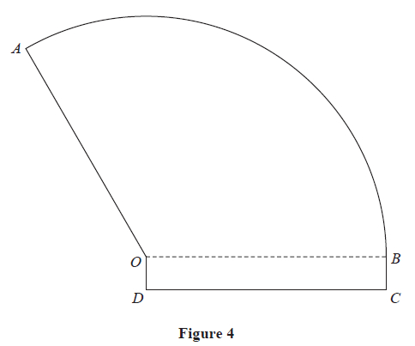
Figure 4 shows the plan view for the design of a stage.
The shape of this design consists of a sector of a circle AOB joined to a rectangle OBCD.
Given that
• the radius of the sector is r metres and angle AOB is θ radians
• the length and width of the rectangle are r metres and 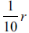 metres respectively
• the total area of the stage is 240 m²
(a) show that the perimeter of the stage, P metres, is given by
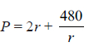
You must make your method clear.

(4)
Using algebraic differentiation,
(b) find the value of r for which P has a stationary value.

(3)
(c) Prove, by further differentiation, that this value of r gives the minimum perimeter of the stage.

(2)

(Total for question = 9 marks)

(Q15 9MA0/01, June 2025)

Q11.
The curve C, in the standard Cartesian plane, is defined by the equation
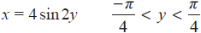
The curve C passes through the origin O
(a) Find the value of at the origin.

(2)
(b) (i) Use the small angle approximation for sin 2y to find an equation linking x and y for points close to the origin.
(ii) Explain the relationship between the answers to (a) and (b)(i).

(2)
(c) Show that, for all points (x, y) lying on C,
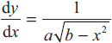
where a and b are constants to be found.

(3)

(Total for question = 7 marks)

(Q14 9MA0/01, June 2019)

Q12.
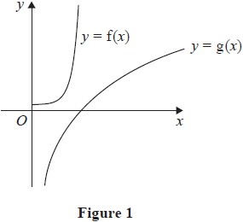
Figure 1 shows a sketch of the curves with equations y = f(x) and y = g(x) where
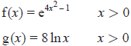
(a) Find
(i) f'(x)
(ii) g'(x)

(2)
Given that f'(x) = g'(x) at x = α
(b) show that α satisfies the equation
4x² + 2lnx − 1 = 0

(2)
The iterative formula
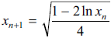
is used with x₁ = 0.6 to find an approximate value for α
(c) Calculate, giving each answer to 4 decimal places,
(i) the value of x²
(ii) the value of α

(3)

(Total for question = 7 marks)

(Q06 9MA0/02, June 2024)

Q13.
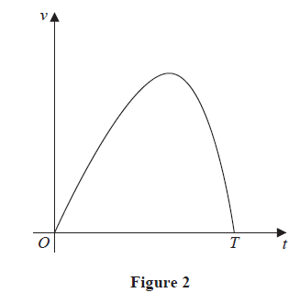
A racing car is driven along a straight road.
Figure 2 shows a graph of the speed of the car as it travels along the road.
The car starts from rest and is driven for T seconds before stopping.
The speed of the car is modelled by the equation
v = 15t − te^{0.2t} 0 ≤ t ≤ T
where t seconds is the time after the car starts to move.
According to the model,
(a) find the value of T, giving your answer to one decimal place,

(2)
(b) show that the maximum speed of the car occurs when
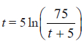

(4)
Using the iteration formula
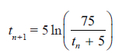 with t₁ = 8
(c) (i) find the value of t₃ to 3 decimal places,
(ii) find, by repeated iteration, the time taken for the car to reach maximum speed.

(3)

(Total for question = 9 marks)

(Q09 9MA0/01, June 2025)

Q14.
The value of a car, £V, is modelled by the equation
V = 1500 + Ae^{−kt}
where A and k are positive constants and t is the age of the car in years.
Given that
• the initial value of the car was £20 000
• the value of the car was £12 000 when it was 2.5 years old
(a) find a complete equation for the model, giving the exact value of A and the value of k to 3 significant figures.

(4)
(b) Show that the rate of change in the value of the car can be expressed in the form
−k(V − 1500)

(3)
(c) State a limitation of this model.

(1)

(Total for question = 8 marks)

(Q11 9MA0/01, June 2025)

Q15.
A spherical mint of radius 5 mm is placed in the mouth and sucked.
Four minutes later, the radius of the mint is 3 mm.
In a simple model, the rate of decrease of the radius of the mint is inversely proportional to the square of the radius.
Using this model and all the information given,
(a) find an equation linking the radius of the mint and the time.
(You should define the variables that you use.)

(5)
(b) Hence find the total time taken for the mint to completely dissolve.
Give your answer in minutes and seconds to the nearest second.

(2)
(c) Suggest a limitation of the model.

(1)

(Total for question = 8 marks)

(Q10 9MA0/02, June 2018)

Q16.
A scientist is studying a population of mice on an island.
The number of mice, N, in the population, t months after the start of the study, is modelled by the equation
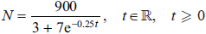
(a) Find the number of mice in the population at the start of the study.

(1)
(b) Show that the rate of growth is given by 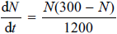

(4)
The rate of growth is a maximum after T months.
(c) Find, according to the model, the value of T.

(4)
According to the model, the maximum number of mice on the island is P.
(d) State the value of P.

(1)

(Total for question = 10 marks)

(Q14 9MA0/02, June 2018)

Q17.
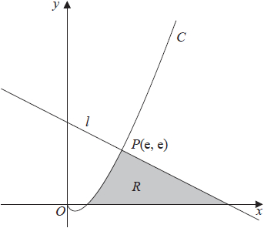
Figure 2
Figure 2 shows a sketch of part of the curve C with equation y = x ln x, x > 0
The line l is the normal to C at the point P(e, e)
The region R, shown shaded in Figure 2, is bounded by the curve C, the line l and the x-axis.
Show that the exact area of R is Ae² + B where A and B are rational numbers to be found.

(10)

(Total for question = 10 marks)

(Q13 9MA0/02, June 2018)

Q18.
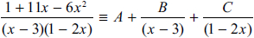
(a) Find the values of the constants A, B and C.

(4)
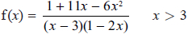
(b) Prove that f (x) is a decreasing function.

(3)

(Total for question = 7 marks)

(Q11 9MA0/02, June 2018)

Q19.
Water flows at a constant rate into a large container.
There is a tap at the bottom of the container.
At time t hours after the tap was opened
• the volume of water in the container is V m³
• water is flowing into the container at a constant rate of 0.45 m³ per hour
• water is leaving the container through the tap at a rate of 0.3V m³ per hour
(a) Show that
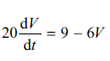

(2)
Given that when the tap was opened, there was 0.25 m³ of water in the container,
(b) solve the differential equation to show that
V = P − Qe^{−kt}
where P, Q and k are positive constants to be found.

(5)
Given that
• the capacity of the container is 2 m³
• the tap remains open
• the water continues to flow into the tank at the same rate
(c) determine whether the container will ever become full, giving a reason for your answer.

(2)

(Total for question = 9 marks)

(Q10 9MA0/02, June 2025)

Q20.
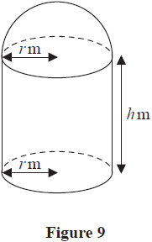
A manufacturer produces a storage tank.
The tank is modelled in the shape of a hollow circular cylinder closed at one end with a
hemispherical shell at the other end as shown in Figure 9.
The walls of the tank are assumed to have negligible thickness.
The cylinder has radius r metres and height h metres and the hemisphere has radius r metres.
The volume of the tank is 6 m³.
(a) Show that, according to the model, the surface area of the tank, in m², is given by
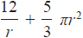

(4)
The manufacturer needs to minimise the surface area of the tank.
(b) Use calculus to find the radius of the tank for which the surface area is a minimum.

(4)
(c) Calculate the minimum surface area of the tank, giving your answer to the nearest integer.

(2)

(Total for question = 10 marks)

(Q13 9MA0/02, June 2019)

Q21.
In this question you must show all stages of your working.
Solutions relying entirely on calculator technology are not acceptable.
A new type of car is released for sale.
The total number of this type of car sold, N, in a particular region, t months after the cars were released for sale, is modelled by the equation
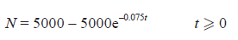
Use the equation of the model to answer parts (a), (b), (c) and (d).
(a) Find the total number of cars sold in the first 3 months.

(2)
Given that N = 3000 when t = T
(b) find the value of T giving the answer to 2 decimal places.

(3)
(c) Find the rate of increase in the total number of cars sold when t = 3, giving the answer to 3 significant figures.

(2)
After a marketing campaign, the total number of cars sold is expected to rise and have an upper limit of 6500
(d) Using this information, suggest one refinement to the model.

(1)

(Total for question = 8 marks)

(Q09 9MA0/02, June 2025)

Q22.
The curve C has equation
(x + y)³ = 3x² − 3y − 2
(a) Find an expression for in terms of x and y.

(5)
The point P(1, 0) lies on C.
(b) Show that the normal to C at P has equation
y = −2x + 2

(2)
(c) Prove that the normal to C at P does not meet C again.
You should use algebra for your proof and make your reasoning clear.

(5)

(Total for question = 12 marks)

(Q15 9MA0/02, June 2024)

Q23.
In this question you must show all stages of your working.
Solutions relying on calculator technology are not acceptable.
A curve has equation
x³ + 2xy + 3y² = 47
(a) Find in terms of x and y

(4)
The point P(−2, 5) lies on the curve.
(b) Find the equation of the normal to the curve at P, giving your answer in the form ax + by + c = 0 , where a, b and c are integers to be found.

(3)

(Total for question = 7 marks)

(Q07 9MA0/02, June 2023)

Q24.
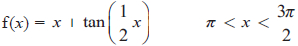
Given that the equation f(x) = 0 has a single root α
(a) show that α lies in the interval [3.6, 3.7]

(2)
(b) Find f'(x)

(2)
(c) Using 3.7 as a first approximation for α, apply the Newton–Raphson method once to obtain a second approximation for α. Give your answer to 3 decimal places.

(2)

(Total for question = 6 marks)

(Q03 9MA0/01, June 2024)

Q25.
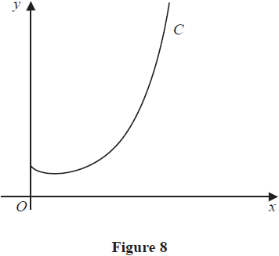
Figure 8 shows a sketch of the curve C with equation y = x^{x} , x > 0
(a) Find, by firstly taking logarithms, the x coordinate of the turning point of C.

(5)
The point P(α, 2) lies on C.
(b) Show that 1.5 < α < 1.6

(2)
A possible iteration formula that could be used in an attempt to find α is
Using this formula with x₁ = 1.5
(c) find x₄ to 3 decimal places,

(2)
(d) describe the long-term behaviour of x_{n}

(2)

(Total for question = 11 marks)

(Q11 9MA0/02, June 2019)

Q26.
The curve C has parametric equations
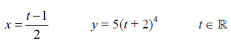
The point P with x coordinate −3 lies on C.
(a) Find the y coordinate of P.

(2)
(b) Find a Cartesian equation for C, giving the answer in the form y = f (x)

(2)
(c) Hence, or otherwise, find the gradient of C at the point P.

(3)

(Total for question = 7 marks)

(Q05 9MA0/02, June 2025)

Q27.
In this question you must show all stages of your working.
Solutions relying entirely on calculator technology are not acceptable.
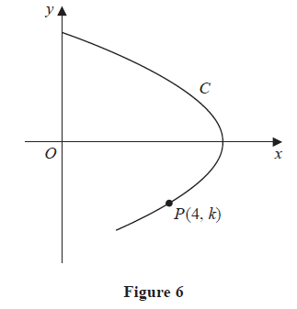
Figure 6 shows a sketch of the curve C with parametric equations
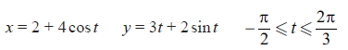
The point P(4, k), where k is a negative constant, lies on the curve.
(a) Find the exact value of k

(2)
The point Q lies on the curve.
Given that the gradient of the curve at Q is 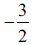
(b) find the value of t at Q, giving your answer to 3 significant figures.

(6)

(Total for question = 8 marks)

(Q16 9MA0/02/M, June 2025)

Q28.
The curve C has parametric equations
(a) Show that a Cartesian equation for C is
where A and B are integers to be found.

(3)
The curve C cuts the y-axis at the point P
(b) Show that the equation of the tangent to C at P can be written in the form
ax + by = c ln 5
where a, b and c are integers to be found.

(4)

(Total for question = 7 marks)

(Q09 9MA0/02, June 2023)

Q29.
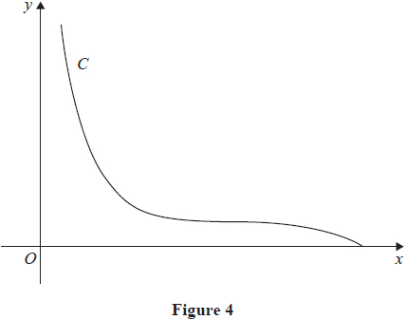
Figure 4 shows a sketch of the curve C with parametric equations
The point P with coordinates (4, 2) lies on C.
(a) Using parametric differentiation, show that the tangent to C at P has equation
3x + 4y = 20

(5)
The curve C is used to model the profile of a slide at a water park.
Units are in metres, with y being the height of the slide above water level.
(b) Find, according to the model, the greatest height of the slide above water level.

(1)

(Total for question = 6 marks)

(Q10 9MA0/02, June 2024)

Q30.
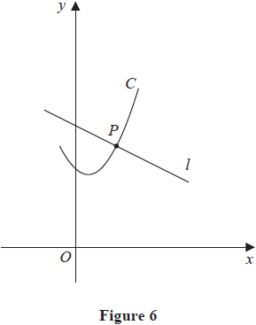
Figure 6 shows a sketch of the curve C with parametric equations
x = 2tant + 1 y = 2sec²t + 3 ≤ t ≤
The line l is the normal to C at the point P where t =
(a) Using parametric differentiation, show that an equation for l is
y = −0.5x + 8.5

(5)
(b) Show that all points on C satisfy the equation
y = 0.5(x − 1)² + 5

(2)
The straight line with equation
y = −0.5x + k where k is a constant
intersects C at two distinct points.
(c) Find the range of possible values for k.

(5)

(Total for question = 12 marks)

(Q16 9MA0/02, June 2022)

Q31.
The functions f and g are defined by
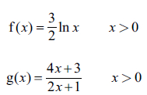
(a) Find gf(e²) writing your answer in simplest form.

(2)
(b) Prove that g is a decreasing function.

(3)
(c) Find the range of the function fg

(2)

(Total for question = 7 marks)

(Q07 9MA0/02/M, June 2025)

Q32.
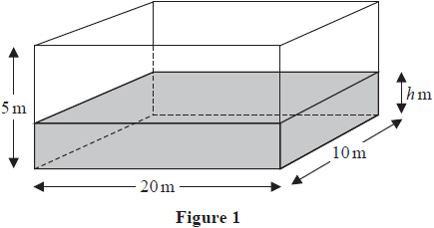
A tank in the shape of a cuboid is being filled with water.
The base of the tank measures 20 m by 10 m and the height of the tank is 5 m, as shown in Figure 1.
At time t minutes after water started flowing into the tank the height of the water was h m and the volume of water in the tank was V m³
In a model of this situation
• the sides of the tank have negligible thickness
• the rate of change of V is inversely proportional to the square root of h
(a) Show that
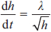
where λ is a constant.

(3)
Given that
• initially the height of the water in the tank was 1.44 m
• exactly 8 minutes after water started flowing into the tank the height of the water was 3.24 m
(b) use the model to find an equation linking h with t, giving your answer in the form
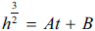
where A and B are constants to be found.

(5)
(c) Hence find the time taken, from when water started flowing into the tank, for the tank to be completely full.

(2)

(Total for question = 10 marks)

(Q11 9MA0/02, June 2023)

Q33.
A curve has equation y = f(x), where
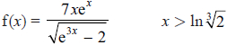
(a) Show that
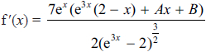
where A and B are constants to be found.

(5)
(b) Hence show that the x coordinates of the turning points of the curve are solutions of the equation
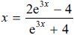

(2)
The equation 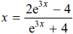 has two positive roots α and β where β > α
A student uses the iteration formula
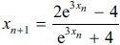
in an attempt to find approximations for α and β
Diagram 1 shows a plot of part of the curve with equation 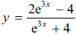 and part of the line with equation y = x
Using the Diagram below
(c) draw a staircase diagram to show that the iteration formula starting with x¹ = 1 can be used to find an
approximation for β

(1)
Only use the copy of Diagram 1 if you need to redraw your answer to part (c).
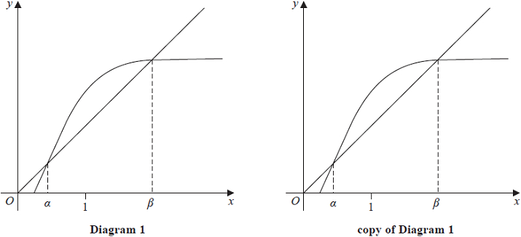
Use the iteration formula with x¹ = 1, to find, to 3 decimal places,
(d) (i) the value of x²
(ii) the value of β

(3)
Using a suitable interval and a suitable function that should be stated
(e) show that α = 0.432 to 3 decimal places.

(2)

(Total for question = 13 marks)

(Q15 9MA0/01, June 2023)

Q34.
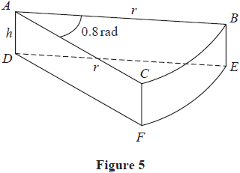
A company makes toys for children.
Figure 5 shows the design for a solid toy that looks like a piece of cheese.
The toy is modelled so that
• face ABC is a sector of a circle with radius r cm and centre A
• angle BAC = 0.8 radians
• faces ABC and DEF are congruent
• edges AD, CF and BE are perpendicular to faces ABC and DEF
• edges AD, CF and BE have length h cm
Given that the volume of the toy is 240 cm³
(a) show that the surface area of the toy, S cm², is given by
S = 0.8r² + 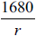
making your method clear.

(4)
Using algebraic differentiation,
(b) find the value of r for which S has a stationary point.

(4)
(c) Prove, by further differentiation, that this value of r gives the minimum surface area of the toy.

(2)

(Total for question = 10 marks)

(Q15 9MA0/01, June 2022)

Q35.
Given that θ is measured in radians, prove, from first principles, that
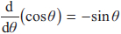
You may assume the formula for cos (A ± B) and that as h → 0, 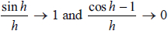

(5)

(Total for question = 5 marks)

(Q09 9MA0/02, June 2018)

Q36.
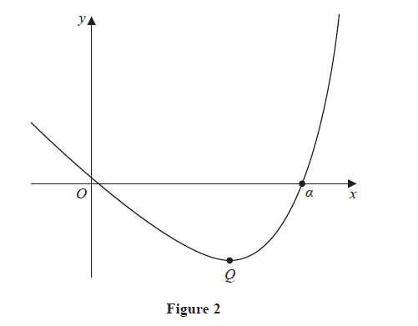
Figure 2 shows a sketch of the curve with equation y = f(x), where
f(x) = 2^{x} − 10x
The curve crosses the x-axis at x = α, α > 1, as shown in Figure 2.
(a) Show that α lies in the interval [5, 6]

(2)
Given that f ′(x) = p × 2^{x} − 10
(b) state the value of the constant p

(1)
(c) Taking x₀ = 6 as a first approximation to α, apply the Newton-Raphson method once to f(x) to obtain a second approximation to α
Show your method and give your answer to 3 significant figures.

(2)
The curve has a minimum turning point at Q, shown in Figure 2.
(d) Use the answer to part (b) to find the x coordinate of Q
Show your working and give your answer to 3 significant figures.

(2)

(Total for question = 7 marks)

(Q04 9MA0/02/M, June 2025)

Q37.
The curve C has equation y = f (x)
The curve
• passes through the point P(3, −10)
• has a turning point at P
Given that
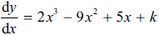
where k is a constant,
(a) show that k = 12

(2)
(b) Hence find the coordinates of the point where C crosses the y-axis.

(3)

(Total for question = 5 marks)

(Q05 9MA0/02, June 2023)

Q38.
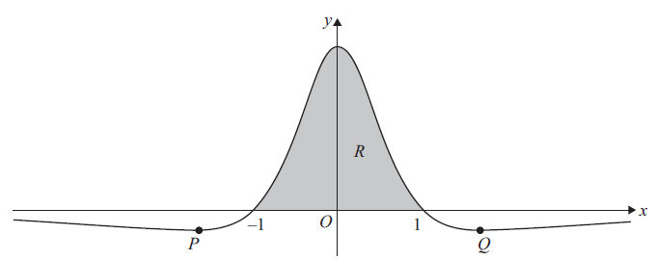
Figure 5 shows a sketch of part of the curve with equation y = f (x), where
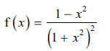
The curve
• intersects the x-axis at −1 and 1
• has minimum turning points at P and Q
as shown in Figure 5.
(a) Use calculus to find the exact coordinates of P.

(5)
(b) Using the substitution x = tanθ show that
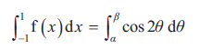
where α and β are constants to be found.

(5)
The finite region R, shown shaded in Figure 5, is bounded by the x-axis and the curve.
(c) Use algebraic integration to find the area of R.

(3)

(Total for question = 13 marks)

(Q15 9MA0/02, June 2025)

Q39.
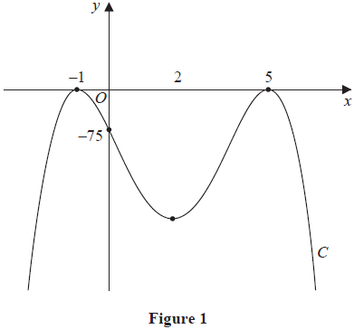
Figure 1 shows a sketch of a curve C with equation y = f(x), where f(x) is a quartic expression in x.
The curve
• has maximum turning points at (−1, 0) and (5, 0)
• crosses the y-axis at (0, −75)
• has a minimum turning point at x = 2
(a) Find the set of values of x for which
f′(x) ≥ 0
writing your answer in set notation.

(2)
(b) Find the equation of C. You may leave your answer in factorised form.

(3)
The curve C₁ has equation y = f(x) + k, where k is a constant.
Given that the graph of C₁ intersects the x-axis at exactly four places,
(c) find the range of possible values for k.

(2)

(Total for question = 7 marks)

(Q07 9MA0/01, June 2025)

Q40.
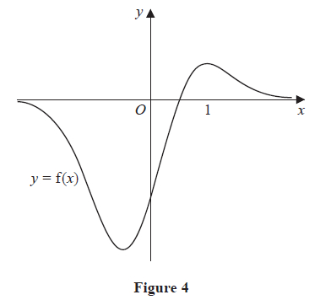
Figure 4 shows a sketch of the curve with equation y = f(x) where
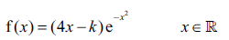
and where k is a positive constant.
Given that the curve has a maximum turning point at x = 1
(a) show that k = 2

(4)
(b) Hence show that the only other turning point is at 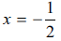

(1)
Given that the equation f(x) = p, where p is a constant, has exactly two distinct roots,
(c) find the range of possible values for p

(3)

(Total for question = 8 marks)

(Q10 9MA0/02/M, June 2025)

Q41.
The function f is defined by
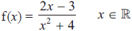
(a) Show that
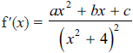
where a, b and c are constants to be found.

(3)
(b) Hence, using algebra, find the values of x for which f is decreasing.
You must show each step in your working.

(3)

(Total for question = 6 marks)

(Q05 9MA0/01, June 2024)

Q42.
The function f is defined by
f(x) = 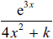
where k is a positive constant.
(a) Show that
f'(x) = (12x² − 8x + 3k) g(x)
where g(x) is a function to be found.

(3)
Given that the curve with equation y = f(x) has at least one stationary point,
(b) find the range of possible values of k.

(3)

(Total for question = 6 marks)

(Q12 9MA0/02, June 2022)

Q43.
A scientist is studying the number of bees and the number of wasps on an island.
The number of bees, measured in thousands, N_{b} , is modelled by the equation
N_{b} = 45 + 220 e^{0.05t}
where t is the number of years from the start of the study.
According to the model,
(a) find the number of bees at the start of the study,

(1)
(b) show that, exactly 10 years after the start of the study, the number of bees was increasing at a rate of approximately 18 thousand per year.

(3)
The number of wasps, measured in thousands, N_{w}, is modelled by the equation
N_{w} = 10 + 800 e^{−0.05t}
where t is the number of years from the start of the study.
When t = T, according to the models, there are an equal number of bees and wasps.
(c) Find the value of T to 2 decimal places.

(4)

(Total for question = 8 marks)

(Q10 9MA0/01, June 2022)

Q44.
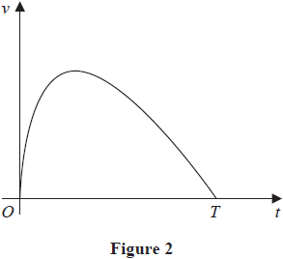
A car stops at two sets of traffic lights.
Figure 2 shows a graph of the speed of the car, v ms⁻¹, as it travels between the two sets of traffic lights.
The car takes T seconds to travel between the two sets of traffic lights.
The speed of the car is modelled by the equation
v = (10 − 0.4t) ln(t + 1) 0 ≤ t ≤ T
where t seconds is the time after the car leaves the first set of traffic lights.
According to the model,
(a) find the value of T

(1)
(b) show that the maximum speed of the car occurs when
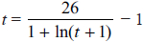

(4)
Using the iteration formula
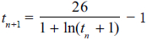
with t₁ = 7
(c) (i) find the value of t₃ to 3 decimal places,
(ii) find, by repeated iteration, the time taken for the car to reach maximum speed.

(3)

(Total for question = 8 marks)

(Q08 9MA0/01, June 2022)

Q45.
(a) Show that the x coordinates of the turning points of the curve with equation y = f(x) satisfy the equation tan x = 4

(4)
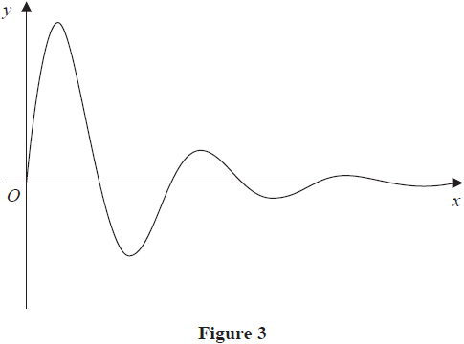
Figure 3 shows a sketch of part of the curve with equation y = f(x).
(b) Sketch the graph of H against t where
showing the long-term behaviour of this curve.

(2)
The function H(t) is used to model the height, in metres, of a ball above the ground t seconds after it has been kicked.
Using this model, find
(c) the maximum height of the ball above the ground between the first and second bounce.

(3)
(d) Explain why this model should not be used to predict the time of each bounce.

(1)

(Total for question = 10 marks)

(Q12 9MA0/01, June 2019)

Q46.
Given that
y = 2x²
use differentiation from first principles to show that
= 4x

(Total for question = 3 marks)

(Q04 9MA0/02, June 2022)

Q47.
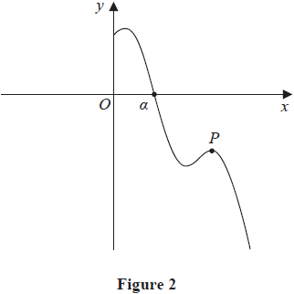
Figure 2 shows a sketch of part of the curve with equation y = f(x) where
f(x) = 8 sin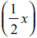 − 3x + 9 x > 0
and x is measured in radians.
The point P, shown in Figure 2, is a local maximum point on the curve.
(a) find the x coordinate of P, giving your answer to 3 significant figures.

(4)
The curve crosses the x-axis at x = α, as shown in Figure 2.
Given that, to 3 decimal places, f(4) = 4.274 and f(5) = −1.212
(b) explain why α must lie in the interval [4, 5]

(1)
(c) Taking x₀ = 5 as a first approximation to α, apply the Newton-Raphson method once
to f(x) to obtain a second approximation to α.
Show your method and give your answer to 3 significant figures.

(2)

(Total for question = 7 marks)

(Q06 9MA0/02, June 2022)

Q48.
A curve C has equation
(a) Find (i)
(ii)

(3)
(b) Verify that C has a stationary point when x = 4

(2)
(c) Determine the nature of this stationary point, giving a reason for your answer.

(2)

(Total for question = 7 marks)

(Q02 9MA0/01, June 2018)

Q49.
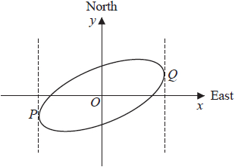
Figure 4
Figure 4 shows a sketch of the curve with equation x² − 2xy + 3y² = 50
(a) Show that 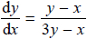

(4)
The curve is used to model the shape of a cycle track with both x and y measured in km.
The points P and Q represent points that are furthest west and furthest east of the origin O, as shown in Figure 4.
Using part (a),
(b) find the exact coordinates of the point P.

(5)
(c) Explain briefly how to find the coordinates of the point that is furthest north of the origin O. (You do not need to carry out this calculation).

(1)

(Total for question = 10 marks)

(Q09 9MA0/01, June 2018)

Q50.
Given that
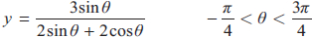
show that
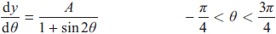
where A is a rational constant to be found.

(5)

(Total for question = 5 marks)

(Q05 9MA0/01, June 2018)

