Name: _______________________________________________
Integration Exam Questions
Topic Test and Revision
Date:
Time: 300
Total marks available: 257
Total marks achieved: ______
Calculator Allowed
Mathvault.io

Questions
Q1.
Show that
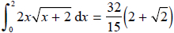

(7)

(Total for question = 7 marks)

(Q13 9MA0/01, June 2018)

Q2.
Given that
(a) show that 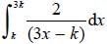 is independent of k,

(4)
(b) show that 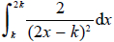 is inversely proportional to k.

(3)

(Total for question = 7 marks)

(Q07 9MA0/01, June 2018)

Q3.
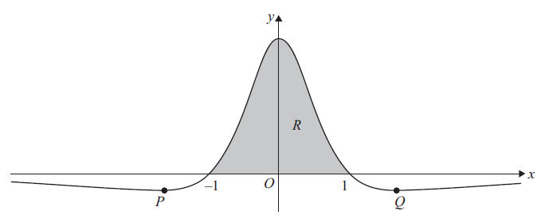
In this question you must show all stages of your working.
Solutions relying on calculator technology are not acceptable.
Figure 5 shows a sketch of part of the curve with equation y = f (x), where
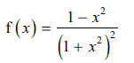
The curve
• intersects the x-axis at −1 and 1
• has minimum turning points at P and Q
as shown in Figure 5.
(a) Use calculus to find the exact coordinates of P.

(5)
(b) Using the substitution x = tanθ show that
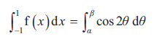
where α and β are constants to be found.

(5)
The finite region R, shown shaded in Figure 5, is bounded by the x-axis and the curve.
(c) Use algebraic integration to find the area of R.

(3)

(Total for question = 13 marks)

(Q15 9MA0/02, June 2025)

Q4.
The height above ground, H metres, of a passenger on a roller coaster can be modelled by the differential equation
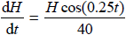
where t is the time, in seconds, from the start of the ride.
Given that the passenger is 5 m above the ground at the start of the ride,
(a) show that H = 5e^{0.1 sin (0.25t )}

(5)
(b) State the maximum height of the passenger above the ground.

(1)
The passenger reaches the maximum height, for the second time, T seconds after the start of the ride.
(c) Find the value of T.

(2)

(Total for question = 8 marks)

(Q10 9MA0/01, June 2018)

Q5.
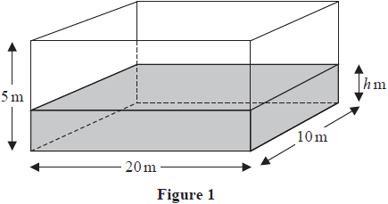
A tank in the shape of a cuboid is being filled with water.
The base of the tank measures 20 m by 10 m and the height of the tank is 5 m, as shown in Figure 1.
At time t minutes after water started flowing into the tank the height of the water was h m and the volume of water in the tank was V m³
In a model of this situation
• the sides of the tank have negligible thickness
• the rate of change of V is inversely proportional to the square root of h
(a) Show that
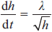
where λ is a constant.

(3)
Given that
• initially the height of the water in the tank was 1.44 m
• exactly 8 minutes after water started flowing into the tank the height of the water was 3.24 m
(b) use the model to find an equation linking h with t, giving your answer in the form
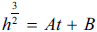
where A and B are constants to be found.

(5)
(c) Hence find the time taken, from when water started flowing into the tank, for the tank to be completely full.

(2)

(Total for question = 10 marks)

(Q11 9MA0/02, June 2023)

Q6.
(a) Express 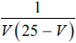 in partial fractions.

(2)
The volume, V microlitres, of a plant cell t hours after the plant is watered is modelled by the differential equation
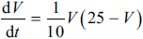
The plant cell has an initial volume of 20 microlitres.
(b) Find, according to the model, the time taken, in minutes, for the volume of the plant cell to reach 24 microlitres.

(5)
(c) Show that
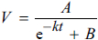
where A, B and k are constants to be found.

(3)
The model predicts that there is an upper limit, L microlitres, on the volume of the plant cell.
(d) Find the value of L, giving a reason for your answer.

(2)

(Total for question = 12 marks)

(Q12 9MA0/02, June 2024)

Q7.
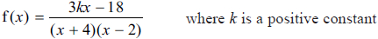
(a) Express f(x) in partial fractions in terms of k.

(3)
(b) Hence find the exact value of k for which
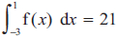

(4)

(Total for question = 7 marks)

(Q10 9MA0/02, June 2023)

Q8.
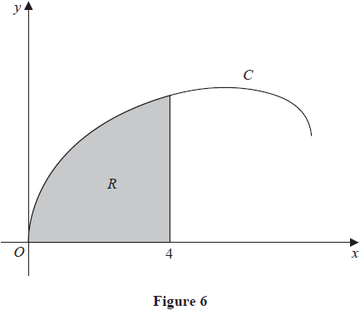
Figure 6 shows a sketch of the curve C with parametric equations
x = 8 sin²t y = 2 sin2t + 3 sint 0 ≤ t ≤
The region R, shown shaded in Figure 6, is bounded by C, the x-axis and the line with equation x = 4
(a) Show that the area of R is given by
(8 − 8 cos4t + 48sin²t cost)dt
where a is a constant to be found.

(5)
(b) Hence, using algebraic integration, find the exact area of R.

(4)

(Total for question = 9 marks)

(Q16 9MA0/01, June 2022)

Q9.
The table below shows corresponding values of x and y for y = e^{−x2}
The values of y are given to 4 decimal places as appropriate.
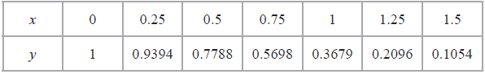
(a) Using the trapezium rule with all the values of y in the table, find an estimate for
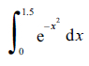
giving your answer to 3 significant figures.

(3)
Using your answer to part (a) and making your method clear, estimate
(b) (i) 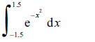
(ii) 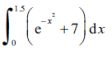

(3)

(Total for question = 6 marks)

(Q05 9MA0/02/M, June 2025)

Q10.
(a) Use the substitution u = 4 − to show that
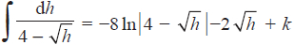
where k is a constant

(6)
A team of scientists is studying a species of slow growing tree.
The rate of change in height of a tree in this species is modelled by the differential equation
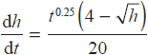
where h is the height in metres and t is the time, measured in years, after the tree is planted.
(b) Find, according to the model, the range in heights of trees in this species.

(2)
One of these trees is one metre high when it is first planted.
According to the model,
(c) calculate the time this tree would take to reach a height of 12 metres, giving your answer to 3 significant figures.

(7)

(Total for question = 15 marks)

(Q14 9MA0/02, June 2019)

Q11.
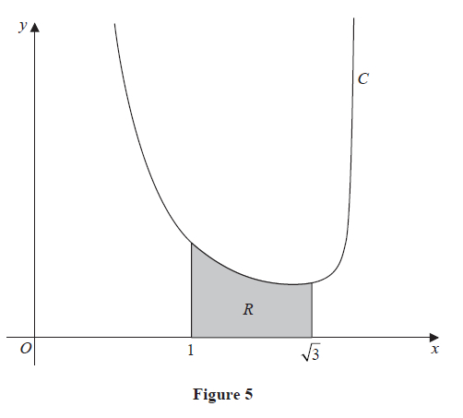
Figure 5 shows a sketch of the curve C with equation
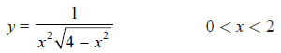
The region R, shown shaded in Figure 5, is bounded by C, the line with equation x = 1, the x-axis and the line with equation x = √3
(a) Use the substitution x = 2 sin u to show that the area of R is given by
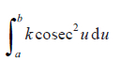
where a, b and k are constants to be found.

(4)
(b) Hence, using algebraic integration, find the exact area of R.
Give your answer in simplest form.

(3)

(Total for question = 7 marks)

(Q16 9MA0/01, June 2025)

Q12.
In this question you must show all stages of your working.
Solutions relying on calculator technology are not acceptable.
Show that
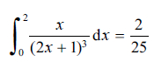

(Total for question = 5 marks)

(Q13 9MA0/01, June 2025)

Q13.
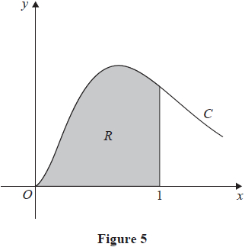
In this question you must show all stages of your working.
Solutions relying entirely on calculator technology are not acceptable.
Figure 5 shows a sketch of part of the curve C with equation
The finite region R, shown shaded in Figure 5, is bounded by
• the curve C
• the line with equation x = 1
• the x-axis
Find the exact area of R, giving your answer in the form
A + Be⁻³
where A and B are rational numbers to be found.

(5)

(Total for question = 5 marks)

(Q11 9MA0/02, June 2024)

Q14.
(a) Given that a is a positive constant, use the substitution x = a sin²θ to show that
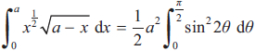

(4)
(b) Hence use algebraic integration to show that
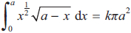
where k is a constant to be found.

(4)

(Total for question = 8 marks)

(Q13 9MA0/01, June 2024)

Q15.
The curve C with equation
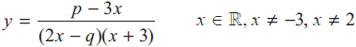
where p and q are constants, passes through the point 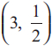 and has two vertical asymptotes with equations x = 2 and x = –3
(a) (i) Explain why you can deduce that q = 4
(ii) Show that p = 15

(3)
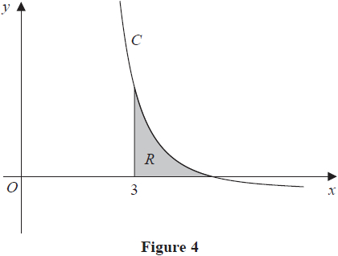
Figure 4 shows a sketch of part of the curve C. The region R, shown shaded in Figure 4, is bounded by the curve C, the x-axis and the line with equation x = 3
(b) Show that the exact value of the area of R is aln 2 + bln 3, where a and b are rational constants to be found.

(8)

(Total for question = 11 marks)

(Q13 9MA0/01, June 2019)

Q16.
The number of mice on an island is being monitored.
When monitoring began there were 4000 mice on the island.
In a simple model, the number of mice x, in thousands, is modelled by the equation
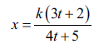
where k is a constant and t is the number of years after monitoring began.
(a) Find a complete equation for this model.

(2)
(b) Hence calculate the long-term population of mice predicted by this model.

(1)
In a second model, the number of mice x, in thousands, is modelled by the differential equation
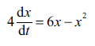
where t is the number of years after monitoring began.
(c) Write 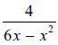 in partial fraction form.

(3)
(d) Solve the differential equation with the given initial condition to show that
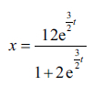

(5)
(e) Hence find the long-term population of mice predicted by this second model.

(1)

(Total for question = 12 marks)

(Q15 9MA0/02/M, June 2025)

Q17.
Water flows at a constant rate into a large container.
There is a tap at the bottom of the container.
At time t hours after the tap was opened
• the volume of water in the container is V m³
• water is flowing into the container at a constant rate of 0.45 m³ per hour
• water is leaving the container through the tap at a rate of 0.3V m³ per hour
(a) Show that
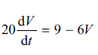

(2)
Given that when the tap was opened, there was 0.25 m³ of water in the container,
(b) solve the differential equation to show that
V = P − Qe^{−kt}
where P, Q and k are positive constants to be found.

(5)
Given that
• the capacity of the container is 2 m³
• the tap remains open
• the water continues to flow into the tank at the same rate
(c) determine whether the container will ever become full, giving a reason for your answer.

(2)

(Total for question = 9 marks)

(Q10 9MA0/02, June 2025)

Q18.
In this question you must show all stages of your working.
Solutions relying on calculator technology are not acceptable.
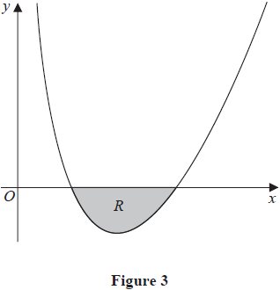
Figure 3 shows a sketch of part of a curve with equation
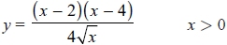
The region R, shown shaded in Figure 3, is bounded by the curve and the x-axis.
Find the exact area of R, writing your answer in the form + b, where a and b are constants to be found.

(Total for question = 6 marks)

(Q08 9MA0/02, June 2022)

Q19.
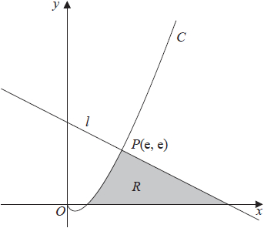
Figure 2
Figure 2 shows a sketch of part of the curve C with equation y = x ln x, x > 0
The line l is the normal to C at the point P(e, e)
The region R, shown shaded in Figure 2, is bounded by the curve C, the line l and the x-axis.
Show that the exact area of R is Ae² + B where A and B are rational numbers to be found.

(10)

(Total for question = 10 marks)

(Q13 9MA0/02, June 2018)

Q20.
A spherical mint of radius 5 mm is placed in the mouth and sucked.
Four minutes later, the radius of the mint is 3 mm.
In a simple model, the rate of decrease of the radius of the mint is inversely proportional to the square of the radius.
Using this model and all the information given,
(a) find an equation linking the radius of the mint and the time.
(You should define the variables that you use.)

(5)
(b) Hence find the total time taken for the mint to completely dissolve.
Give your answer in minutes and seconds to the nearest second.

(2)
(c) Suggest a limitation of the model.

(1)

(Total for question = 8 marks)

(Q10 9MA0/02, June 2018)

Q21.
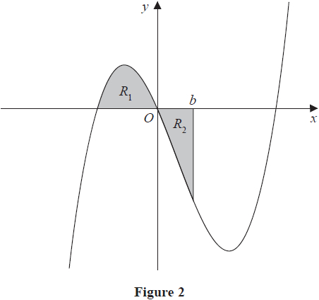
Figure 2 shows a sketch of part of the curve with equation y = x(x + 2)(x – 4).
The region R₁ shown shaded in Figure 2 is bounded by the curve and the negative x-axis.
(a) Show that the exact area of R₁ is

(4)
The region R₂ also shown shaded in Figure 2 is bounded by the curve, the positive x-axis
and the line with equation x = b, where b is a positive constant and 0 < b < 4
Given that the area of R₁ is equal to the area of R₂
(b) verify that b satisfies the equation
(b + 2)² (3b² – 20b + 20) = 0

(4)
The roots of the equation 3b² – 20b + 20 = 0 are 1.225 and 5.442 to 3 decimal places.
The value of b is therefore 1.225 to 3 decimal places.
(c) Explain, with the aid of a diagram, the significance of the root 5.442

(2)

(Total for question = 10 marks)

(Q08 9MA0/01, June 2019)

Q22.
(a) Express 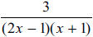 in partial fractions.

(3)
When chemical A and chemical B are mixed, oxygen is produced.
A scientist mixed these two chemicals and measured the total volume of oxygen produced over a period of time.
The total volume of oxygen produced, V m³, t hours after the chemicals were mixed, is modelled by the differential equation
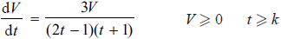
where k is a constant.
Given that exactly 2 hours after the chemicals were mixed, a total volume of 3 m³ of oxygen had been produced,
(b) solve the differential equation to show that
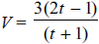

(5)
The scientist noticed that
• there was a time delay between the chemicals being mixed and oxygen being produced
• there was a limit to the total volume of oxygen produced
Deduce from the model
(c) (i) the time delay giving your answer in minutes,
(ii) the limit giving your answer in m³

(2)

(Total for question = 10 marks)

(Q14 9MA0/02, June 2022)

Q23.
(a) Express 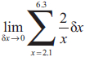 as an integral.

(1)
(b) Hence show that
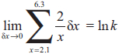
where k is a constant to be found.

(2)

(Total for question = 3 marks)

(Q04 9MA0/01, June 2022)

Q24.
In this question you must show all stages of your working.
Solutions relying entirely on calculator technology are not acceptable.
(a) Find the first three terms, in ascending powers of x, of the binomial expansion of
writing each term in simplest form.

(4)
(b) Using the answer to part (a) and using algebraic integration, estimate the value of
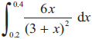
giving your answer to 4 significant figures.

(4)
(c) Find, using algebraic integration, the exact value of
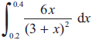
giving your answer in the form a ln b + c, where a, b and c are constants to be found.

(5)

(Total for question = 13 marks)

(Q13 9MA0/02, June 2023)

Q25.
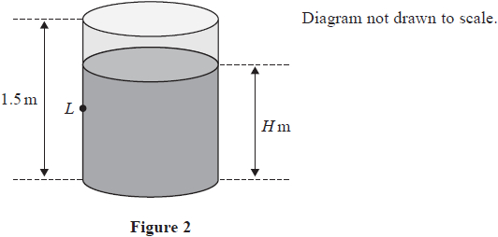
Figure 2 shows a cylindrical tank of height 1.5 m.
Initially the tank is full of water.
The water starts to leak from a small hole, at a point L, in the side of the tank.
While the tank is leaking, the depth, H metres, of the water in the tank is modelled by the differential equation
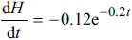
where t hours is the time after the leak starts.
Using the model,
(a) show that
where A and B are constants to be found,

(3)
(b) find the time taken for the depth of the water to decrease to 1.2 m. Give your answer in hours and minutes, to the nearest minute.

(3)
In the long term, the water level in the tank falls to the same height as the hole.
(c) Find, according to the model, the height of the hole from the bottom of the tank.

(2)

(Total for question = 8 marks)

(Q07 9MA0/01, June 2024)

Q26.
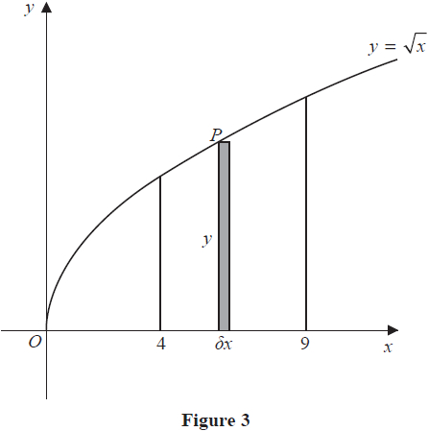
Figure 3 shows a sketch of the curve with equation
The point P(x, y) lies on the curve.
The rectangle, shown shaded on Figure 3, has height y and width
Calculate
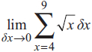

(Total for question = 3 marks)

(Q05 9MA0/02, June 2019)

Q27.
In this question you must show all stages of your working.
Solutions relying entirely on calculator technology are not acceptable.
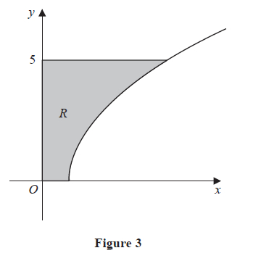
Figure 3 shows a sketch of part of the curve with equation
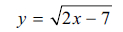
The region R, shown shaded in Figure 3, is bounded by the curve, the x-axis, the y-axis and the line with equation y = 5
Find the exact area of R

(Total for question = 6 marks)

(Q08 9MA0/02/M, June 2025)

Q28.
Find
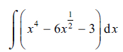
giving the answer in simplest form.

(Total for question = 4 marks)

(Q02 9MA0/02, June 2025)

Q29.
(a) Express 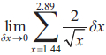 as an integral.

(1)
(b) Hence show that
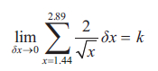
where k is an integer to be found.
(Solutions relying on calculator technology are not acceptable.)

(2)

(Total for question = 3 marks)

(Q05 9MA0/01, June 2025)

Q30.
A balloon is being inflated.
In a simple model,
• the balloon is modelled as a sphere
• the rate of increase of the radius of the balloon is inversely proportional to the square root of the radius of the balloon
At time t seconds, the radius of the balloon is r cm.
(a) Write down a differential equation to model this situation.

(1)
At the instant when t = 10
• the radius is 16 cm
• the radius is increasing at a rate of 0.9 cm s⁻¹
(b) Solve the differential equation to show that
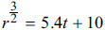

(5)
(c) Hence find the radius of the balloon when t = 20
Give your answer to the nearest millimetre.

(2)
(d) Suggest a limitation of the model.

(1)

(Total for question = 9 marks)

(Q14 9MA0/01, June 2024)

Q31.
Find
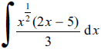
writing each term in simplest form.

(Total for question = 4 marks)

(Q01 9MA0/01, June 2023)

Q32.
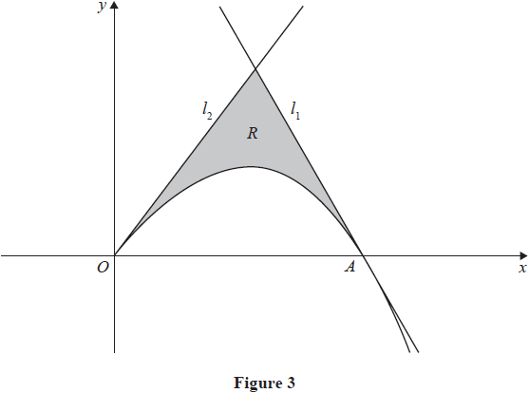
In this question you must show all stages of your working.
Solutions relying entirely on calculator technology are not acceptable.
Figure 3 shows a sketch of part of the curve with equation
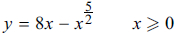
The curve crosses the x-axis at the point A.
(a) Verify that the x coordinate of A is 4

(1)
The line l₁ is the tangent to the curve at A.
(b) Use calculus to show that an equation of line l₁ is
12x + y = 48

(3)
The line l₂ has equation y = 8x
The region R, shown shaded in Figure 3, is bounded by the curve, the line l₁ and the line l₂
(c) Use algebraic integration to find the exact area of R.

(5)

(Total for question = 9 marks)

(Q10 9MA0/01, June 2024)

