Name: _______________________________________________
Sequence and Series Exam Questions
Date:
Time:
Total marks available: 231
Total marks achieved: ______
Mathvault.io

Questions
Q1.
In this question you must show all stages of your working.
Solutions relying on calculator technology are not acceptable.
Given that the first three terms of a geometric series are
12cosθ 5 + 2sinθ and 6tanθ
(a) show that
4sin²θ − 52sinθ + 25 = 0

(3)
Given that θ is an obtuse angle measured in radians,
(b) solve the equation in part (a) to find the exact value of θ

(2)
(c) show that the sum to infinity of the series can be expressed in the form
k(1 − )
where k is a constant to be found.

(5)

(Total for question = 10 marks)

(Q15 9MA0/02, June 2022)

Q2.
A sequence of terms a₁, a₂, a₃, ... is defined by
a₁ = 3
a_{n+1} = 8 − a_{n}
(a) (i) Show that this sequence is periodic.
(ii) State the order of this periodic sequence.

(2)
(b) Find the value of
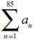

(2)

(Total for question = 4 marks)

(Q03 9MA0/02, June 2022)

Q3.
In an arithmetic series
• the first term is 16
• the 21st term is 24
(a) Find the common difference of the series.

(2)
(b) Hence find the sum of the first 500 terms of the series.

(2)

(Total for question = 4 marks)

(Q01 9MA0/02, Oct 2021)

Q4.
Jamie takes out an interest free loan of £8100
Jamie makes a payment every month to pay back the loan.
Jamie repays £400 in month 1, £390 in month 2, £380 in month 3, and so on, so that the amounts repaid each month form an arithmetic sequence.
(a) Show that Jamie repays £290 in month 12

(1)
After Jamie's Nth payment, the loan is completely paid back.
(b) Show that N² − 81N + 1620 = 0

(2)
(c) Hence find the value of N.

(2)

(Total for question = 5 marks)

(Q02 9MA0/02, June 2024)

Q5.
The first three terms of an arithmetic sequence are
6k, 10 and 2k
where k is a constant.
(a) Find the value of k.

(2)
(b) Hence find the value of the sum of the first 50 terms of this sequence.

(3)

(Total for question = 5 marks)

(Q03 9MA0/01, June 2025)

Q6.
(i) In an arithmetic series, the first term is a and the common difference is d.
Show that
S_{n} = [2a + (n − 1)d]

(3)
(ii) James saves money over a number of weeks to buy a printer that costs £64
He saves £10 in week 1, £9.20 in week 2, £8.40 in week 3 and so on, so that the weekly amounts he saves form an arithmetic sequence.
Given that James takes n weeks to save exactly £64
(a) show that
n² − 26n + 160 = 0

(2)
(b) Solve the equation
n² − 26n + 160 = 0

(1)
(c) Hence state the number of weeks James takes to save enough money to buy the printer, giving a brief reason for your answer.

(1)

(Total for question = 7 marks)

(Q13 9MA0/01, June 2022)

Q7.
(a) Find the first three terms, in ascending powers of x, of the binomial expansion of
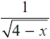
giving each coefficient in its simplest form.

(4)
The expansion can be used to find an approximation to
Possible values of x that could be substituted into this expansion are:
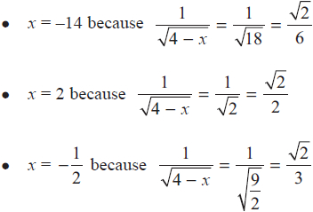
(b) Without evaluating your expansion,
(i) state, giving a reason, which of the three values of x should not be used

(1)
(ii) state, giving a reason, which of the three values of x would lead to the most accurate approximation to

(1)

(Total for question = 6 marks)

(Q04 9MA0/01, June 2019)

Q8.
In the binomial expansion of
(a + 2x)⁷ where a is a constant
the coefficient of x⁴ is 15 120
Find the value of a.

(Total for question = 3 marks)

(Q04 9MA0/02, Oct 2020)

Q9.
(a) Find, in ascending powers of x, the first four terms of the binomial expansion of
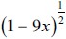
giving each term in simplest form.

(3)
(b) Give a reason why 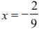 should not be used in the expansion to find an approximation to √3

(1)

(Total for question = 4 marks)

(Q02 9MA0/01, June 2024)

Q10.
(a) Find the first four terms, in ascending powers of x, of the binomial expansion of
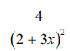
writing each term in simplest form.

(4)
(b) Find the range of values of x for which this expansion is valid.

(1)

(Total for question = 5 marks)

(Q06 9MA0/02/M, June 2025)

Q11.
(a) Find the first four terms, in ascending powers of x, of the binomial expansion of
writing each term in simplest form.

(4)
A student uses this expansion with x = to find an approximation for
Using the answer to part (a) and without doing any calculations,
(b) state whether this approximation will be an overestimate or an underestimate of giving a brief reason for your answer.

(1)

(Total for question = 5 marks)

(Q07 9MA0/02, June 2022)

Q12.
In this question you must show all stages of your working.
Solutions relying entirely on calculator technology are not acceptable.
(a) Find the first three terms, in ascending powers of x, of the binomial expansion of
writing each term in simplest form.

(4)
(b) Using the answer to part (a) and using algebraic integration, estimate the value of
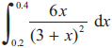
giving your answer to 4 significant figures.

(4)
(c) Find, using algebraic integration, the exact value of
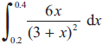
giving your answer in the form a ln b + c, where a, b and c are constants to be found.

(5)

(Total for question = 13 marks)

(Q13 9MA0/02, June 2023)

Q13.
The value, £V, of a vintage car t years after it was first valued on 1st January 2001, is modelled by the equation
V = Ap^{t} where A and p are constants
Given that the value of the car was £32 000 on 1st January 2005 and £50 000 on 1st January 2012
(a) (i) find p to 4 decimal places,
(ii) show that A is approximately 24 800

(4)
(b) With reference to the model, interpret
(i) the value of the constant A,
(ii) the value of the constant p.

(2)
Using the model,
(c) find the year during which the value of the car first exceeds £100 000

(4)

(Total for question = 10 marks)

(Q12 9MA0/01, June 2018)

Q14.
A sequence u₁, u₂, u₃ ... is defined by
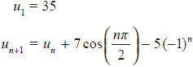
(a) (i) Show that u₂ = 40
(ii) Find the value of u₃ and the value of u₄

(3)
Given that the sequence is periodic with order 4
(b) (i) write down the value of u₅
(ii) find the value of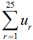

(3)

(Total for question = 6 marks)

(Q02 9MA0/02, June 2023)

Q15.
A sequence u₁, u₂, u₃, ... is defined by
u_{n+1} = ku_{n} − 5
u₁ = 6
where k is a positive constant.
Given that u₃ = −1
(a) show that
6k² − 5k − 4 = 0

(2)
(b) Hence
(i) find the value of k,
(ii) find the value of 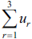

(3)

(Total for question = 5 marks)

(Q04 9MA0/02, June 2024)

Q16.
A sequence of terms a₁, a₂, a₃,… is defined by
a₁ = 4
a_{n + 1} = ka_{n} + 3
where k is a constant.
Given that
• 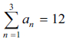
• all terms of the sequence are different
find the value of k

(Total for question = 4 marks)

(Q03 9MA0/02/M, June 2025)

Q17.
In this question you must show all stages of your working.
Given that the first three terms of a geometric sequence are
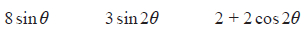
and 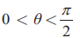
(a) show that
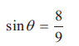

(4)
Hence, or otherwise
(b) prove that S∞ exists

(2)
(c) find the value of S∞ − S₁₀ giving your answer to 2 significant figures.

(3)

(Total for question = 9 marks)

(Q13 9MA0/02/M, June 2025)

Q18.
A sequence of numbers a₁, a₂, a₃, ... is defined by
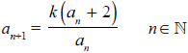
where k is a constant.
Given that
• the sequence is a periodic sequence of order 3
• a₁ = 2
(a) show that
k² + k − 2 = 0

(3)
(b) For this sequence explain why k ≠ 1

(1)
(c) Find the value of
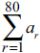

(3)

(Total for question = 7 marks)

(Q13 9MA0/01, Oct 2020)

Q19.
The sequence u₁, u₂, u₃,... is defined by
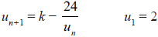
where k is an integer.
Given that u₁ + 2u₂ + u₃ = 0
(a) show that
3k² − 58k + 240 = 0

(3)
(b) Find the value of k, giving a reason for your answer.

(2)
(c) Find the value of u₃

(1)

(Total for question = 6 marks)

(Q03 9MA0/01, Oct 2021)

Q20.
In this question you should show all stages of your working.
Solutions relying entirely on calculator technology are not acceptable.
A company made a profit of £20 000 in its first year of trading, Year 1
A model for future trading predicts that the yearly profit will increase by 8% each year, so that the yearly profits will form a geometric sequence.
According to the model,
(a) show that the profit for Year 3 will be £23 328

(1)
(b) find the first year when the yearly profit will exceed £65 000

(3)
(c) find the total profit for the first 20 years of trading, giving your answer to the nearest £1000

(2)

(Total for question = 6 marks)

(Q05 9MA0/01, Oct 2021)

Q21.
Show that
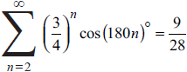

(Total for question = 3 marks)

(Q09 9MA0/02, Oct 2021)

Q22.
The first three terms of a geometric sequence are
3k + 4 12 − 3k k + 16
where k is a constant.
(a) Show that k satisfies the equation
3k² − 62k + 40 = 0

(2)
Given that the sequence converges,
(b) (i) find the value of k, giving a reason for your answer,
(ii) find the value of S∞
(5)

(Total for question = 7 marks)

(Q09 9MA0/01, June 2023)

Q23.
The first 3 terms of a geometric sequence are
where k is a constant.
(a) Using algebra and making your reasoning clear, prove that 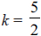

(3)
(b) Hence find the sum to infinity of the geometric sequence.

(3)

(Total for question = 6 marks)

(Q09 9MA0/01, June 2024)

Q24.
A competitor is running a 20 kilometre race.
She runs each of the first 4 kilometres at a steady pace of 6 minutes per kilometre.
After the first 4 kilometres, she begins to slow down.
In order to estimate her finishing time, the time that she will take to complete each subsequent kilometre is modelled to be 5% greater than the time that she took to complete the previous kilometre.
Using the model,
(a) show that her time to run the first 6 kilometres is estimated to be 36 minutes 55 seconds,

(2)
(b) show that her estimated time, in minutes, to run the r th kilometre, for 5 ≤ r ≤ 20, is
6 × 1.05^{r – 4}

(1)
(c) estimate the total time, in minutes and seconds, that she will take to complete the race.

(4)

(Total for question = 7 marks)

(Q11 9MA0/01, June 2019)

Q25.
A car has six forward gears.
The fastest speed of the car
• in 1st gear is 28 km h^{–1}
• in 6th gear is 115 km h^{–1}
Given that the fastest speed of the car in successive gears is modelled by an
arithmetic sequence,
(a) find the fastest speed of the car in 3rd gear.

(3)
Given that the fastest speed of the car in successive gears is modelled by a
geometric sequence,
(b) find the fastest speed of the car in 5th gear.

(3)

(Total for question = 6 marks)

(Q05 9MA0/01, Oct 2020)

Q26.
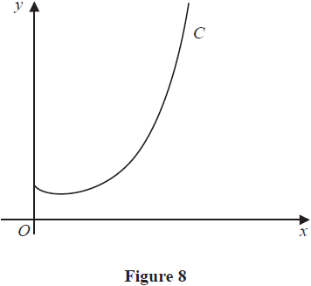
Figure 8 shows a sketch of the curve C with equation y = x^{x} , x > 0
(a) Find, by firstly taking logarithms, the x coordinate of the turning point of C.
(Solutions based entirely on graphical or numerical methods are not acceptable.)

(5)
The point P(α, 2) lies on C.
(b) Show that 1.5 < α < 1.6

(2)
A possible iteration formula that could be used in an attempt to find α is
Using this formula with x₁ = 1.5
(c) find x₄ to 3 decimal places,

(2)
(d) describe the long-term behaviour of x_{n}

(2)

(Total for question = 11 marks)

(Q11 9MA0/02, June 2019)

Q27.
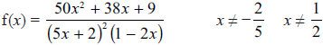
Given that f(x) can be expressed in the form
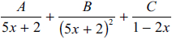
where A, B and C are constants
(a) (i) find the value of B and the value of C
(ii) show that A = 0

(4)
(b) (i) Use binomial expansions to show that, in ascending powers of x
f(x) = p + qx + rx² + ...
where p, q and r are simplified fractions to be found.
(ii) Find the range of values of x for which this expansion is valid.

(7)

(Total for question = 11 marks)

(Q09 9MA0/01, Oct 2021)

Q28.
(a) Find the first four terms, in ascending powers of x, of the binomial expansion of
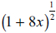
giving each term in simplest form.

(3)
(b) Explain how you could use x = in the expansion to find an approximation for .
There is no need to carry out the calculation.

(2)

(Total for question = 5 marks)

(Q01 9MA0/01, Oct 2020)

Q29.
In this question you must show all stages of your working.
Solutions relying entirely on calculator technology are not acceptable.
A geometric series has common ratio r and first term a.
Given r ≠ 1 and a ≠ 0
(a) prove that
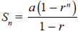

(4)
Given also that S₁₀ is four times S₅
(b) find the exact value of r.

(4)

(Total for question = 8 marks)

(Q15 9MA0/02, Oct 2020)

Q30.
(i) Find the value of
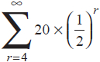

(3)
(ii) Show that
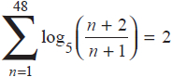

(3)

(Total for question = 6 marks)

(Q08 9MA0/02, June 2019)

Q31.
In this question you must show all stages of your working.
Solutions relying on calculator technology are not acceptable.
Show that
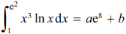
where a and b are rational constants to be found.

(Total for question = 5 marks)

(Q12 9MA0/01, June 2022)

Q32.
(i) Show that 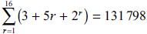

(4)
(ii) A sequence u₁, u₂, u₃, ... is defined by
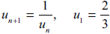
Find the exact value of 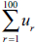

(3)

(Total for question = 7 marks)

(Q04 9MA0/02, June 2018)

Q33.
(a) Express 2 cos θ + 8 sin θ in the form R cos(θ − α) , where R and α are constants, 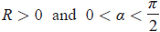
Give the exact value of R and give the value of α in radians to 3 decimal places.

(3)
The first three terms of an arithmetic sequence are
Given that S₉ represents the sum of the first 9 terms of this sequence as x varies,
(b) (i) find the exact maximum value of S₉
(ii) deduce the smallest positive value of x at which this maximum value of S₉ occurs.

(3)

(Total for question = 6 marks)

(Q08 9MA0/02, June 2023)

Q34.
In a geometric series the common ratio is r and sum to n terms is S_{n}
Given
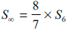
show that r = ± , where k is an integer to be found.

(4)

(Total for question = 4 marks)

(Q10 9MA0/02, Specimen papers )

Q35.
(a) Use the binomial expansion, in ascending powers of x, to show that
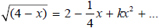
where k is a rational constant to be found.

(4)
A student attempts to substitute x = 1 into both sides of this equation to find an approximate value for .
(b) State, giving a reason, if the expansion is valid for this value of x.

(1)

(Total for question = 5 marks)

(Q07 9MA0/02, Specimen papers )

Q36.
(a) Use binomial expansions to show that 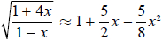

(6)
A student substitutes 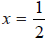 into both sides of the approximation shown in part (a) in an attempt to find an approximation to
(b) Give a reason why the student should not use 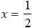

(1)
(c) Substitute 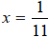 into
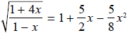
to obtain an approximation to . Give your answer as a fraction in its simplest form.

(3)

(Total for question = 10 marks)

(Q11 9MA0/01, June 2018)

